Lab 10.1 Create a fluid design

In this exercise, you’ll convert a page so it uses a fluid layout and scalable images. When you’re finished, the page will look as shown below when the width of the browser window is reduced.

1. Open the HTML and CSS files that follow and display the page in a browser:

c08x_sampson.html

styles\c08x_speaker.css

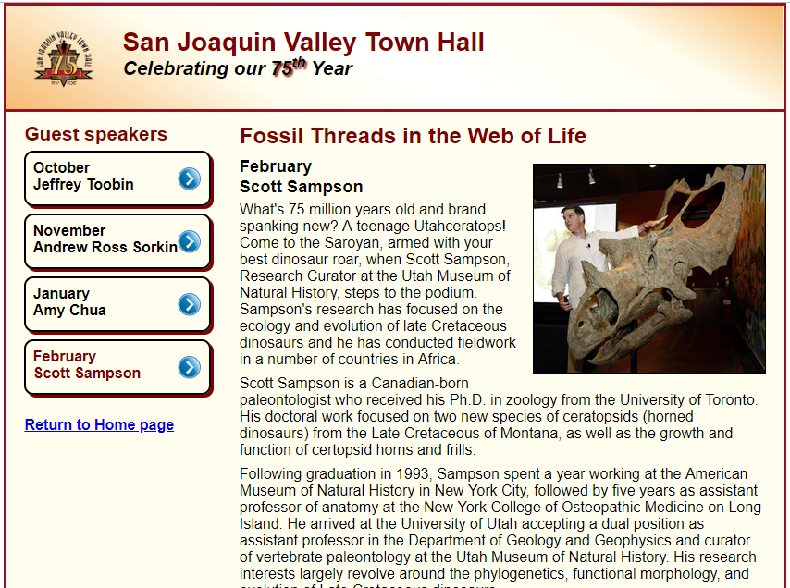

2. Reduce the width of the browser window so it’s less than the width of the page. That way, you’ll be able to see how the page changes as you convert it to a fluid design.

3. Modify the CSS for the body so it takes up 98% of the browser window.

4. Convert the widths of the section, the aside, and the li elements within the navigation menu to percentages.

5. Convert any left or right margins or padding to percentages. (Hint: If any measurements are specified in ems, you can convert them to pixels by multiplying by 16 since that’s the base font size.)

6. Make the image in the article scalable so it’s always 50 percent of the width of the article.

Lab 10.2 Add a media query

In this exercise, you’ll add a media query to the previous page so it provides for tablets in portrait orientation. When you’re finished, the page will look as shown below when the width of the browser window is reduced.

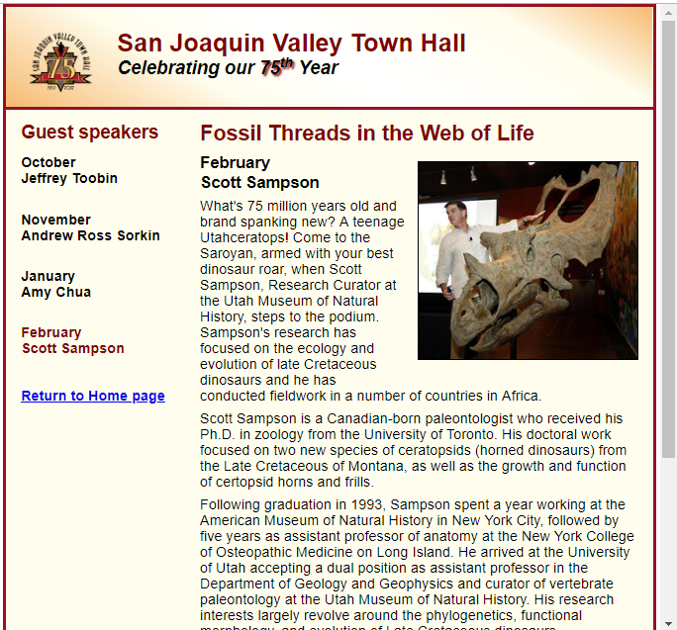

1. Add a meta element to the HTML that sets the width property for the viewport to the device width and the initial zoom factor to 1.

2. Code a media query for the screen media type that has a maximum width of 850 pixels.

3. Within the media query, change the base font size for the page so it’s 90% of the default font size.

4. Remove the border, box shadow, and background image from the list items in the sidebar.

5. Remove the left padding from the links in the sidebar.